“Just Learning!”

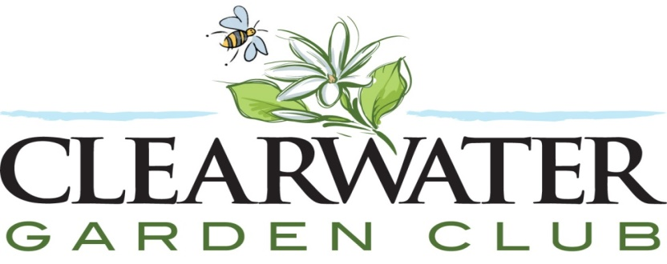

Division I
HORTICULTURE 101

